Bagging
The decision trees suffer from high variance. Bootstrap aggregation, or bagging, is a general-purpose procedure for reducing the variance of a statistical learning method. Averaging a set of observations reduces variance. Hence a natural way to reduce the variance and hence increase the prediction accuracy of a statistical learning method is to take many training sets from the population, build a separate prediction model using each training set, and average the resulting predictions. We can bootstrap, by taking repeated samples from the (single) training data set. In this approach we generate B different bootstrapped training data sets. We then train our method on the bth bootstrapped training set in order to get prediction and finally average all the predictions. This is called bagging. While bagging can improve predictions for many regression methods, it is particularly useful for decision trees. To apply bagging to regression trees, we simply construct B regression trees using B bootstrapped training sets, and average the resulting predictions. These trees are grown deep, and are not pruned. Hence each individual tree has high variance, but low bias. Averaging these B trees reduces the variance. Bagging has been demonstrated to give impressive improvements in accuracy by combining together hundreds or even thousands of trees into a single procedure.

The primary advantage of Bagging and most model aggregation methods is their ability to eliminate weaknesses concerned with model instability. Bagging typically results in improved accuracy over prediction using a single tree. Unfortunately, however, it can be difficult to interpret the resulting model. Recall that one of the advantages of decision trees is the attractive and easily interpreted diagram that results. However, when we bag a large number of trees, it is no longer possible to represent the resulting statistical learning procedure using a single tree, and it is no longer clear which variables are most important to the procedure. Thus, bagging improves prediction accuracy at the expense of interpretability.

Although the collection of bagged trees is much more difficult to interpret than a single tree, one can obtain an overall summary of the importance of each predictor.

Random Forests
A random forest is an ensemble learning approach to supervised learning. Multiple predictive models are developed, and the results are aggregated to improve classification rates. Random forests provide an improvement over bagged trees by way of a small tweak that decorrelates the trees. As in bagging, we build a number of decision trees on bootstrapped training samples. But when building these decision trees, each time a split in a tree is considered, a random sample of m predictors is chosen as split candidates from the full set of p predictors. The split is allowed to use only one of those m predictors. A fresh sample of m predictors is taken at each split, and typically we choose m approximately equal to the square root of the total number of predictors. The algorithm for a random forest involves sampling cases and variables to create a large number of decision trees. Each case is classified by each decision tree. The most common classification for that case is then used as the outcome.

An out-of-bag (OOB) error estimate is obtained by classifying the cases that aren’t selected when building a tree, using that tree. This is an advantage when a validation sample is unavailable. Random forests also provide a natural measure of variable importance.
Random forests are grown using the randomForest() function in the randomForest package. The default number of trees is 500, the default number of variables sampled at each node is sqrt(M), and the minimum node size is 1.
Random forests’ tuning parameter is the number of randomly selected predictors, k, to choose from at each split, and is commonly referred to as m_{try}.

Difference between Bagging and Random Forests
The main difference between bagging and random forests is the choice of predictor subset size m. For instance, if a random forest is built using m = p, then this amounts simply to bagging.

Application in R
randomForest()
By default, randomForest() uses p/3 variables when building a random forest of regression trees, and square root of p variables when building a random forest of classification trees. Recall that bagging is simply a special case of a random forest with m = p. Therefore, the randomForest() function can be used to perform both random forests and bagging. If the response is a factor, randomForest performs classification; if the response is continuous (that is, not a factor), randomForest performs regression. If the response is unspecified, randomForest performs unsupervised learning.

Few differences between classification and regression random forests:
- The default m_{try} is p/3, as opposed to sqrt(p) for classification, where p is the number of predictors.
- The default nodesize is 5, as opposed to 1 for classification. (In the tree building algorithm, nodes with fewer than nodesize observations are not splitted.)
- There is only one measure of variable importance, instead of four.

importance()
A useful feature of the randomForest() function is its variable importance calculation. Since the algorithm uses a large number of bootstrap samples, each data point x has a corresponding set of out-of-bag samples: those samples that don’t contain the point x. The out-of-bag samples can be used is a way similar to N-fold cross validation, to estimate the accuracy of each tree in the ensemble.

To estimate the “importance” of a variable v, the variable’s values are randomly permuted in the out-of-bag samples, and the corresponding decrease in each tree’s accuracy is estimated. If the average decrease over all the trees is large, then the variable is considered important—its value makes a big difference in predicting the outcome. If the average decrease is small, then the variable doesn’t make much difference to the outcome. The algorithm also measures the decrease in node purity that occurs from splitting on a permuted variable (how this variable affects the quality of the tree).

Using the importance() function, we can view the importance of each variable. Two measures of variable importance are reported. The former %IncMSE is based upon the mean decrease of accuracy in predictions on the out of bag samples when a given variable is excluded from the model. The latter IncNodePurity is a measure of the total decrease in node impurity that results from splits over that variable, averaged over all trees. The importance() function returns a matrix of importance measures (larger values are more important).
The random forest algorithm estimates the importance of a variable by looking at how much prediction error increases when (OOB) data for that variable is permuted while all others are left unchanged.

We can calculate the variable importance by setting importance=T in the randomForest() call, and then calling the functions importance() and varImpPlot().

Knowing which variables are most important (or at least, which variables contribute the most to the structure of the underlying decision trees) can help you with variable reduction. This is useful not only for building smaller, faster trees, but for choosing variables to be used by another modeling algorithm, if that’s desired.

varImpPlot()
Plots of these importance measures can be produced using the varImpPlot() function. The option
type | either 1 or 2, specifying the type of importance measure (1=mean decrease in accuracy, 2=mean decrease in node impurity)

Classification Using Random Forest
Use fgl (Measurements of Forensic Glass Fragments) data from MASS library.
This data frame contains the following columns:
RI : refractive index; more precisely the refractive index is 1.518xxxx.
The next 8 measurements are percentages by weight of oxides.
Na : sodium.
Mg :manganese.
Al :aluminium.
Si :silicon.
K :potassium.
Ca :calcium.
Ba :barium.
Fe :iron.
type:The fragments were originally classed into seven types, one of which was absent in this dataset. The categories which occur are window float glass (WinF: 70), window non-float glass (WinNF: 76), vehicle window glass (Veh: 17), containers (Con: 13), tableware (Tabl: 9) and vehicle headlamps (Head: 29).
RI | Na | Mg | Al | Si | K | Ca | Ba | Fe | type
3.01 | 13.64 | 4.49 | 1.1 | 71.78 | 0.06 | 8.75 | 0 | 0 | WinF
-2.26 | 14.86 | 3.67 | 1.74 | 71.87 | 0.16 | 7.36 | 0 | 0.12 | WinNF
-1.35 | 13.14 | 3.45 | 1.76 | 72.48 | 0.6 | 8.38 | 0 | 0.17 | Veh
3.71 | 11.56 | 1.88 | 1.56 | 72.86 | 0.47 | 11.41 | 0 | 0 | Con
-5.01 | 14.4 | 1.74 | 1.54 | 74.55 | 0 | 7.59 | 0 | 0 | Tabl
-1.15 | 14.92 | 0 | 1.99 | 73.06 | 0 | 8.4 | 1.59 | 0 | Head

Note that there are actually four different measures of variable importance implemented in the classification code.
We use mtry=2(or 3) for because for classification problems mtry value is sqrt(8) which is 2.828427.

Load randomForest library:
library(randomForest)

Load data from MASS library
library(MASS)
data(fgl)

set.seed(17)

Create a formula to classify by type(based on all other predictors)

fmla<-as.formula("type ~ .")

Create data sets: 80% training and 20% test.
train <- sample(nrow(fgl ), 0.8*nrow(fgl ))
trainData <- fgl[train,]
testData <- fgl[-train,]

Call randomForest on training data and print the result:

rForest <-randomForest(formula=fmla, mtry=2,data=trainData,importance=TRUE)
print(rForest)

Call:
randomForest(formula = fmla, data = trainData, mtry = 2, importance = TRUE)
Type of random forest: classification
Number of trees: 500
No. of variables tried at each split: 2

OOB estimate of error rate: 22.22%

Confusion matrix:
WinF WinNF Veh Con Tabl Head class.error
WinF 43 8 0 0 0 0 0.1568627
WinNF 7 47 3 2 1 1 0.2295082
Veh 6 3 6 0 0 0 0.6000000
Con 0 2 0 8 0 1 0.2727273
Tabl 0 1 0 0 7 0 0.1250000
Head 1 2 0 0 0 22 0.1200000

Call importance() on the randomForest to determines variable importance:

importance(rForest, type=2)

MeanDecreaseGini
RI 16.897084
Na 15.524285
Mg 18.967652
Al 18.674458
Si 11.446405
K 13.279064
Ca 16.506743
Ba 8.970731
Fe 6.367734

Classify new cases
Use predict function on test data set:
rForestPredict <- predict(rForest,testData)

Evaluate Model Performance
Since this is a classification problem we use confusion matrix:

forestPredTable <- table(testData$type, rForestPredict, dnn=c("Actual", "Predicted"))

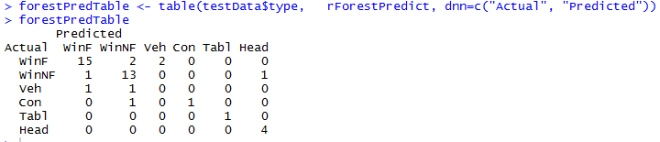

The model missclassified 9 cases out of 43.

Plot of the most important variables
varImpPlot(rForest, type=1)
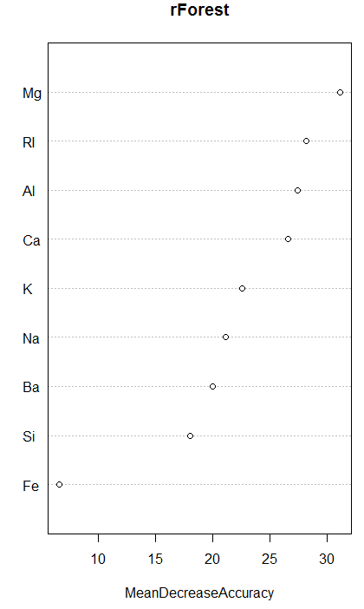

Regression Using Random Forest
The Boston Housing dataset will be used in the random forest tree to predict the median value of owner occupied homes (medv ) in Boston using other explanatory variables listed below:

This data frame contains the following columns:
crim: per capita crime rate by town.
zn: proportion of residential land zoned for lots over 25,000 sq.ft.
indus: proportion of non-retail business acres per town.
chas: Charles River dummy variable (= 1 if tract bounds river; 0 otherwise).
nox: nitrogen oxides concentration (parts per 10 million).
rm: average number of rooms per dwelling.
age: proportion of owner-occupied units built prior to 1940.
dis: weighted mean of distances to five Boston employment centres.
rad: index of accessibility to radial highways.
tax: full-value property-tax rate per $10,000.
ptratio: pupil-teacher ratio by town.

black: 1000(Bk - 0.63)^2 where Bk is the proportion of blacks by town.
lstat: lower status of the population (percent).
medv: median value of owner-occupied homes in $1000s.

Here are the first few rows from Boston data set.

crim | zn | indus | chas | nox | rm | age | dis | rad | tax | ptratio | black | lstat | medv
0.00632 | 18 | 2.31 | 0 | 0.538 | 6.575 | 65.2 | 4.09 | 1 | 296 | 15.3 | 396.9 | 4.98 | 24
0.02731 | 0 | 7.07 | 0 | 0.469 | 6.421 | 78.9 | 4.9671 | 2 | 242 | 17.8 | 396.9 | 9.14 | 21.6
0.02729 | 0 | 7.07 | 0 | 0.469 | 7.185 | 61.1 | 4.9671 | 2 | 242 | 17.8 | 392.83 | 4.03 | 34.7
0.03237 | 0 | 2.18 | 0 | 0.458 | 6.998 | 45.8 | 6.0622 | 3 | 222 | 18.7 | 394.63 | 2.94 | 33.4

Load Boston data from MASS library:
library(randomForest)
library(pROC)
library(MASS)
data(Boston)
set.seed(1341)

Create a formula to regress on medv(based on all other predictors)
fmla<-as.formula("medv ~ .")

Create data sets: 80% training and 20% test.
train <- sample(nrow(Boston ), 0.8*nrow(Boston ))
trainData <- Boston[train,]
testData <- Boston[-train,]
Apply randomForest using mtry=3:
rforestForRegression <- randomForest(formula=fmla, data=trainData, mtry=3)

importance(rforestForRegression, type=1)

Test model on test data:
rForestPrediction <- predict(rforestForRegression,newdata=testData)

Evaluate the model performance
What is OOB error?
What is the relation of MSE(mean square error) with the performance of the model?

Plot of the most important variables

varImpPlot(rforestForRegression)

